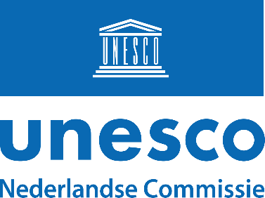

Pre-proposal for a Unesco Chair in the Netherlands (2024 Call)

Title of the proposed Unesco Chair (no acronyms):
Click or tap here to enter text.

Institution:
Click or tap here to enter text.

Proposed Chairholder and – if applicable – team members (incl. contact details):
Click or tap here to enter text.

Describe the proposed Unesco Chair (max. 300 words):
Click or tap here to enter text.

Outline the connection between the proposed Chair’s plans regarding research, education, and public outreach, the current working program of the Netherlands Commission for Unesco, and Unesco’s mandate (max. 200 words):
Click or tap here to enter text.

Chairs can fulfil up to four important roles to the Netherlands Commission for Unesco:
- Expert. Add to the existing expertise of the Netherlands Commission for Unesco, and on this basis contribute in writing or otherwise to projects and initiatives
- Partner. Form a relevant partner in setting up projects and events
- Ambassador. Ensure, by getting the public at large involved, the visibility of the Commission and of Unesco within academia and beyond
- Connector. Strengthen the Dutch contribution to Unesco’s international programs, e.g. by advising ministries and by participating in steering groups of Unesco’s Secretariat, and by forming a bridge between other (inter)national organizations
Explain what role(s) the proposed Chair aims to fulfil, and how (max. 200 words):
Click or tap here to enter text.

