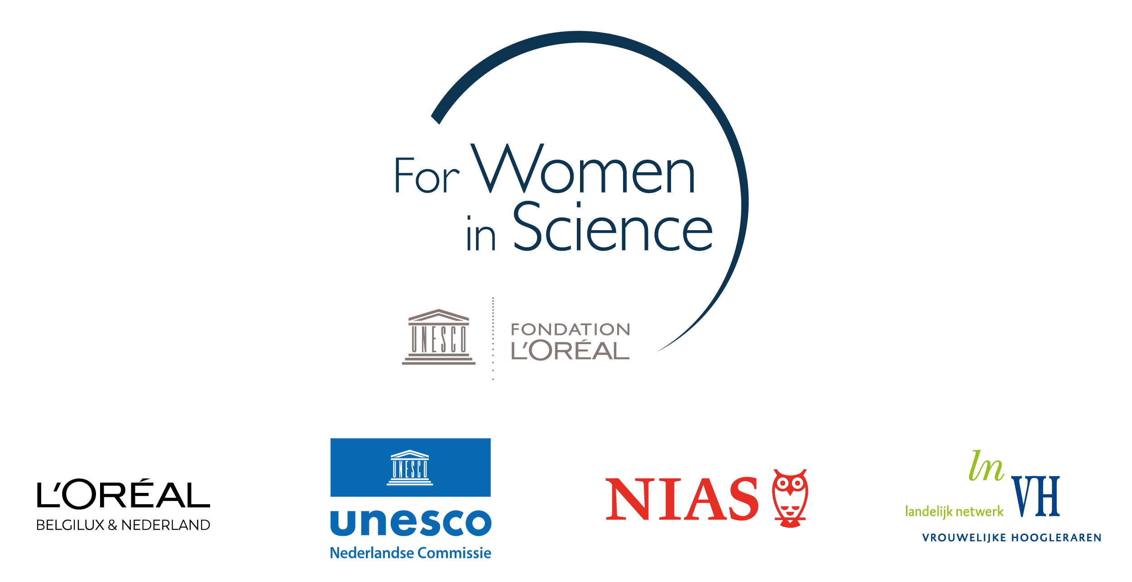

Project proposal form
Dutch L’Oréal-Unesco Fellowship For Women in Science 2023

Provide a full description of the proposed project (max. 1500 words) presenting the items below:

- Research topic and research questions

- Key aims of the project

- Key aspects of innovation in relation to the state of scholarship in the field

- Proposed plan, activities, time schedule and budget

Please provide a work plan for the fellowship at NIAS-KNAW.

Include in the work plan the proposed activities to be carried out and a time schedule reflecting these activities.

Include a budget summary filling the table below in support of this work plan.

The total budget available is € 30,000. For the first two elements (NIAS-KNAW facilities and Replacement costs) the amounts are fixed. Please see the annex of the regulations for instructions (including standard rates) to fill in the budget table.

Budget item | Per month | Total 5 months
NIAS-KNAW facilities | € 2,100 | € 10,500
Replacement costs | € 2,500 | € 12,500
Travel costs | ?
Additional childcare costs | ?
NIAS-KNAW workshop | ?
Total |  | € 30,000

Please note that applying for housing will have an impact on your budget summary. If you are applying for housing, contact Dindy van Maanen at NIAS-KNAW for help with your budget summary: selection@nias.knaw.nl.

- Describe the expected added value of the interdisciplinary NIAS-KNAW environment for the proposed project, and how you would be involved in the NIAS-KNAW community of fellows.

Describe how a fellowship at NIAS-KNAW is of added value and of importance to your proposed project, bearing in mind the key aims of the project. In your description, specify why the interdisciplinary research climate of NIAS-KNAW and the interaction with other fellows will be relevant to your work, and your intended involvement in the NIAS-KNAW community.

- Relevance to society: potential for knowledge dissemination and application

Describe the proposed project’s potential to be of relevance to society. Briefly describe intended modes of dissemination of the project’s results and how the results may have practical application to create societal impact.

