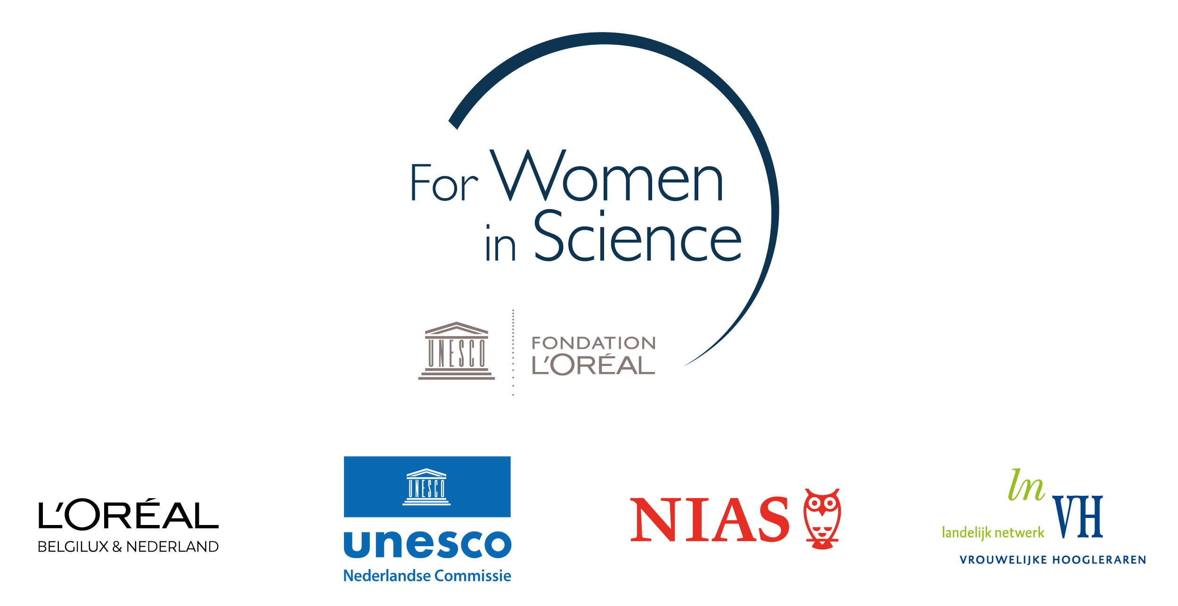
Application form
Dutch L’Oréal-Unesco Fellowship For Women in Science 2023

Please read the Call for Proposals and the FWiS regulations before completing this form.

Details of the applicant

Title(s)
First name
Surname
Place and date of birth
Nationality
Postal address
Telephone
Mobile phone
E-mail
Personal website/social media accounts (if relevant)

Research position and experience

University/research centre
Faculty/Department
Current position
Discipline(s)/specialization
Type of employment contract (please tick) | Temporary Tenure
Master degree(s) – discipline and university/research institute
PhD degree(s) – discipline and university/research institute
Number of years post PhD academic experience
If applicable, list the total duration of maternal/parental leaves taken
Scholarships, grants and awards obtained

Fellowship project proposal

In this section, please provide a summary of the proposed project to be carried out at NIAS-KNAW during the fellowship period (use the separate proposal form to present the full proposal).

Title of the proposed project:

Brief description of the project (max. 150 words):

Key aims of the project:

Key activities to be carried out:

Describe how you expect your work will benefit from a NIAS-KNAW fellowship, and what you would bring to the NIAS-KNAW community (max. 100 words):

Provide a full description of the proposed project (max. 1500 words) in a separate document, using the project proposal form, presenting:

- Research topic and research questions
- Key aims of the project
- Key aspects of innovation in relation to the state of scholarship in the field
- Proposed plan, activities, time schedule and budget
- The added value of the interdisciplinary NIAS-KNAW environment for the proposed project
- Relevance to society: potential for knowledge dissemination and application

Fellowship application – practical details

Application for the academic year 2023/24 (please tick):

First semester (September 2023 - January 2024)

Second semester (February 2024 - June 2024)

No preference

Please indicate if you will apply for housing:

No, I will commute

Yes, for myself / Yes, for myself and my partner

Yes, for myself and my child(ren) / Yes, for myself, my partner, and my child(ren)

Application portfolio

Your application should consist of the following:

- This application form;

- A full project description, using the project proposal form;

- Your CV including a list of your key publications (3 pages max.);

- Two letters of recommendation by (international) specialists in your field;

The letters should make explicit reference to the innovative character of the proposal and to the candidate’s potential to maintain a high level of quality in her future career. Note that the jury will not accept letters from relatives or others that have a personal, non-work related relationship with the candidate that could lead to conflict of interest.

- Two of your most relevant publications (in PDF).

Please submit your application portfolio (7 documents in total) by email no later than 1 March 2023 to dr. Jon Verriet, Netherlands Commission for Unesco: jverriet@unesco.nl.

Your employment contract must cover the duration of the fellowship.
Note that you are only eligible for accommodation if travel time exceeds 1.5 hours (single journey).

