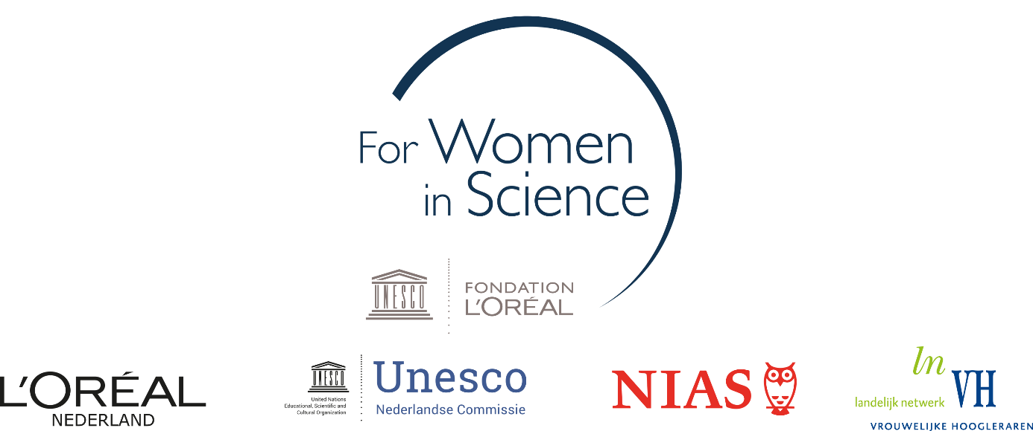
Project proposal form
Dutch L’Oréal-Unesco Fellowship For Women in Science 2021

Provide a full description of the proposed project (max. 1500 words) presenting the items below:

- Research topic and research questions

- Key aims of the project

- Key aspects of innovation in relation to the state of scholarship in the field

- Proposed plan, activities, time schedule and budget

Please provide a work plan for the fellowship at NIAS-KNAW.

Include in the work plan the proposed activities to be carried out, a time schedule reflecting these activities.

Include a budget summary filling the table below in support of this work plan.

The total budget available is € 25.000. Please see the annex of the rules and regulations for instructions (including standard rates) to fill the budget table.

Budget item | Per month (€) | Total 5 months (€)
NIAS-KNAW facilities | 700
Replacement costs | FTE x 3000
Housing (if applicable) | € 1.125 or € 1.250
Travel costs
Additional child care costs
NIAS-KNAW workshop
Total

- Describe the expected added value of the interdisciplinary NIAS-KNAW environment for the proposed project

Describe how a fellowship at NIAS-KNAW is of added value and of importance to your proposed project, bearing in mind the key aims of the project.

Please note that the For Women in Science fellowships are preferably meant for candidates for whom the interdisciplinary research climate of NIAS-KNAW and the interaction with other fellows are particularly attractive, or in other words, when the NIAS-KNAW environment provides particular added value to both candidate and project proposal.

- Relevance to society: potential for knowledge dissemination and application

Describe the potential of the proposed project to be of relevance to society. Briefly describe intended modes of dissemination of the project’s results and how the results may have practical application to create societal impact.

